**WEEK- 3 SPRING CORE MAVEN**

**SUPERSET ID:6393676**

**Exercise 1: Configuring a Basic Spring Application**

**Scenario:**

Your company is developing a web application for managing a library. You need to use the Spring Framework to handle the backend operations.

**SOLUTION:**

**Pom.xml**

<project xmlns="http://maven.apache.org/POM/4.0.0"

xmlns:xsi="http://www.w3.org/2001/XMLSchema-instance"

xsi:schemaLocation="http://maven.apache.org/POM/4.0.0

http://maven.apache.org/xsd/maven-4.0.0.xsd">

<modelVersion>4.0.0</modelVersion>

<groupId>com.library</groupId>

<artifactId>LibraryManagement</artifactId>

<version>1.0-SNAPSHOT</version>

<dependencies>

<!-- Spring Core -->

<dependency>

<groupId>org.springframework</groupId>

<artifactId>spring-context</artifactId>

<version>5.3.34</version> <!-- or latest compatible -->

</dependency>

</dependencies>

</project>

**applicationContext.xml:**

<?xml version="1.0" encoding="UTF-8"?>

<beans xmlns="http://www.springframework.org/schema/beans"

xmlns:xsi="http://www.w3.org/2001/XMLSchema-instance"

xsi:schemaLocation="http://www.springframework.org/schema/beans

http://www.springframework.org/schema/beans/spring-beans.xsd">

<bean id="bookRepository" class="com.library.repository.BookRepository"/>

<bean id="bookService" class="com.library.service.BookService">

<property name="bookRepository" ref="bookRepository"/>

</bean>

</beans>

**com.library.repository:**

**BookRepository:**

package com.library.repository;

public class BookRepository {

public void saveBook(String bookName) {

System.out.println("Book '" + bookName + "' saved to repository.");

}

}

**com.library.service:**

**BookService:**

package com.library.service;

import com.library.repository.BookRepository;

public class BookService {

private BookRepository bookRepository;

// Setter for dependency injection

public void setBookRepository(BookRepository bookRepository) {

this.bookRepository = bookRepository;

}

public void addBook(String bookName) {

System.out.println("Adding book: " + bookName);

bookRepository.saveBook(bookName);

}

}

**LibraryApp:**

package com.library.app;

import org.springframework.context.ApplicationContext;

import org.springframework.context.support.ClassPathXmlApplicationContext;

import com.library.service.BookService;

public class LibraryApp {

public static void main(String[] args) {

ApplicationContext context = new ClassPathXmlApplicationContext("applicationContext.xml");

BookService bookService = (BookService) context.getBean("bookService");

bookService.addBook("The Great Gatsby");

}

}

**OUTPUT:**

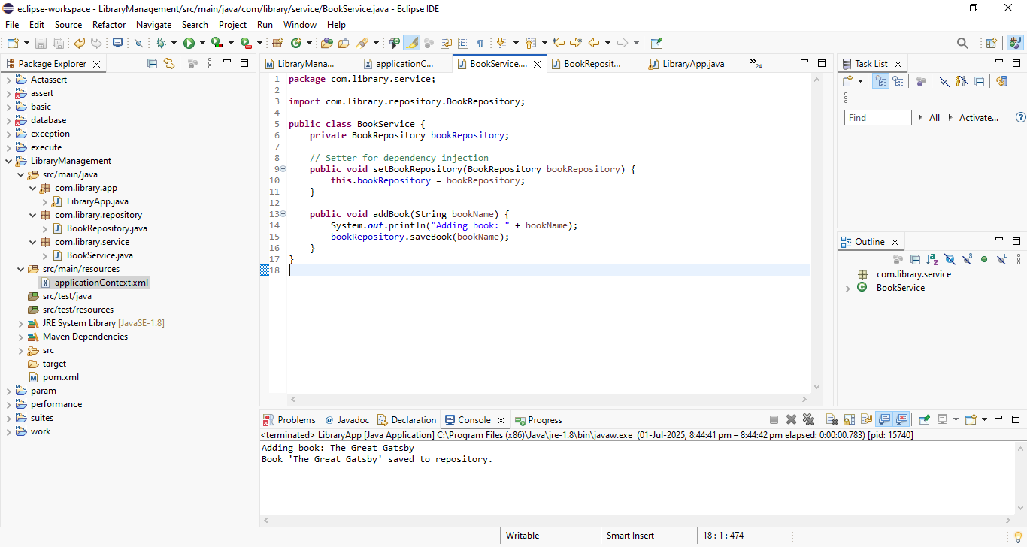

**Exercise 2: Implementing Dependency Injection**

**Scenario:**

In the library management application, you need to manage the dependencies between the BookService and BookRepository classes using Spring's IoC and DI.

**SOLUTION:**

**applicationContext.xml**

<beans xmlns="http://www.springframework.org/schema/beans"

xmlns:xsi="http://www.w3.org/2001/XMLSchema-instance"

xsi:schemaLocation="http://www.springframework.org/schema/beans

http://www.springframework.org/schema/beans/spring-beans.xsd">

<!-- Repository Bean -->

<bean id="bookRepository" class="com.library.repository.BookRepository"/>

<!-- Service Bean with Setter Injection -->

<bean id="bookService" class="com.library.service.BookService">

<property name="bookRepository" ref="bookRepository"/>

</bean>

</beans>

**BookService:**

package com.library.service;

import com.library.repository.BookRepository;

public class BookService {

private BookRepository bookRepository;

// Required setter for Spring DI

public void setBookRepository(BookRepository bookRepository) {

this.bookRepository = bookRepository;

}

public void addBook(String bookName) {

System.out.println("Adding book: " + bookName);

bookRepository.saveBook(bookName);

}

}

**LibraryApp.java**

package com.library.app;

import org.springframework.context.ApplicationContext;

import org.springframework.context.support.ClassPathXmlApplicationContext;

import com.library.service.BookService;

public class LibraryApp {

public static void main(String[] args) {

// Load Spring context from XML

ApplicationContext context = new ClassPathXmlApplicationContext("applicationContext.xml");

// Get BookService bean

BookService bookService = (BookService) context.getBean("bookService");

// Use the service

bookService.addBook("1984 by George Orwell");

}

}

**OUTPUT:**

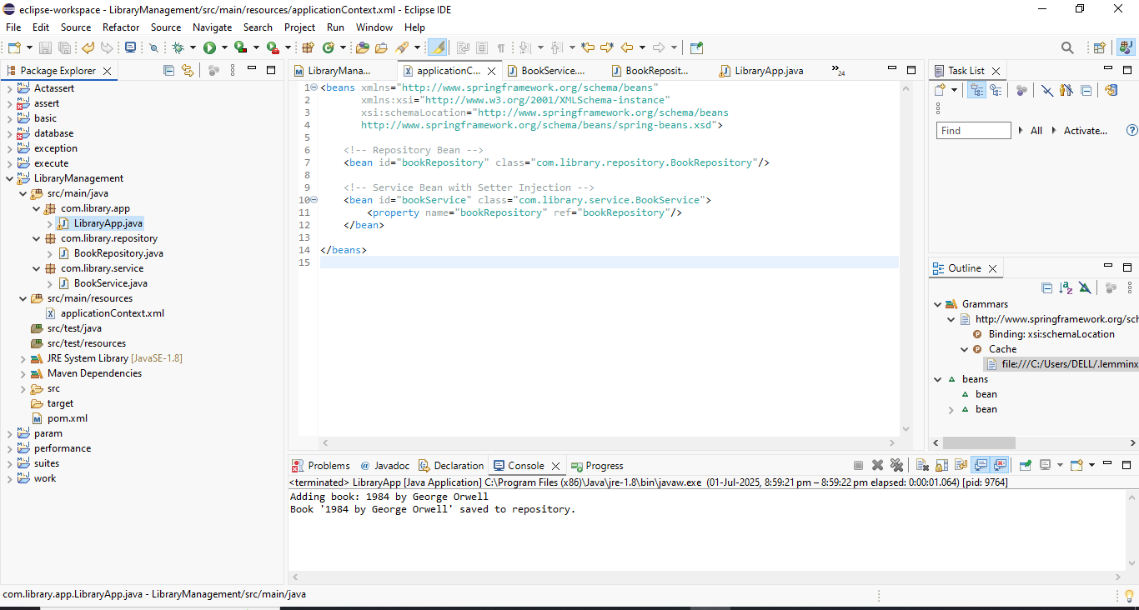

**Exercise 3: Implementing Logging with Spring AOP**

**Scenario:**

The library management application requires logging capabilities to track method execution times.

**SOLUTION:**

**Pom.xml:**

<dependencies>

<!-- Spring Context -->

<dependency>

<groupId>org.springframework</groupId>

<artifactId>spring-context</artifactId>

<version>5.3.34</version>

</dependency>

<!-- Spring AOP -->

<dependency>

<groupId>org.springframework</groupId>

<artifactId>spring-aop</artifactId>

<version>5.3.34</version>

</dependency>

<!-- AspectJ Weaver -->

<dependency>

<groupId>org.aspectj</groupId>

<artifactId>aspectjweaver</artifactId>

<version>1.9.21</version>

</dependency>

</dependencies>

**LoggingAspect.java**

package com.library.aspect;

import org.aspectj.lang.ProceedingJoinPoint;

import org.aspectj.lang.annotation.Around;

import org.aspectj.lang.annotation.Aspect;

@Aspect

public class LoggingAspect {

@Around("execution(* com.library.service.*.*(..))")

public Object logExecutionTime(ProceedingJoinPoint joinPoint) throws Throwable {

long start = System.currentTimeMillis();

Object result = joinPoint.proceed(); // execute the method

long end = System.currentTimeMillis();

System.out.println("Execution time of " + joinPoint.getSignature() + ": " + (end - start) + " ms");

return result;

}

}

**applicationContext.xml**

<beans xmlns="http://www.springframework.org/schema/beans"

xmlns:xsi="http://www.w3.org/2001/XMLSchema-instance"

xmlns:aop="http://www.springframework.org/schema/aop"

xsi:schemaLocation="

http://www.springframework.org/schema/beans

http://www.springframework.org/schema/beans/spring-beans.xsd

http://www.springframework.org/schema/aop

http://www.springframework.org/schema/aop/spring-aop.xsd">

<!-- Enable annotation-based AOP -->

<aop:aspectj-autoproxy/>

<!-- Bean Definitions -->

<bean id="bookRepository" class="com.library.repository.BookRepository"/>

<bean id="bookService" class="com.library.service.BookService">

<property name="bookRepository" ref="bookRepository"/>

</bean>

<!-- Register Logging Aspect -->

<bean id="loggingAspect" class="com.library.aspect.LoggingAspect"/>

</beans>

**LibraryApp.java**

package com.library.app;

import org.springframework.context.ApplicationContext;

import org.springframework.context.support.ClassPathXmlApplicationContext;

import com.library.service.BookService;

public class LibraryApp {

public static void main(String[] args) {

ApplicationContext context = new ClassPathXmlApplicationContext("applicationContext.xml");

BookService bookService = (BookService) context.getBean("bookService");

// Test method to trigger logging

bookService.addBook("To Kill a Mockingbird");

}

}

**OUTPUT:**

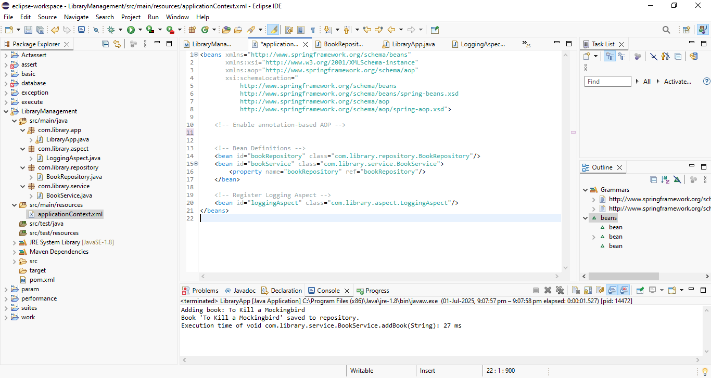

**Exercise 4: Creating and Configuring a Maven Project**

**Scenario:**

You need to set up a new Maven project for the library management application and add Spring dependencies.

**SOLUTION:**

**Pom.xml:**

<project xmlns="http://maven.apache.org/POM/4.0.0"

xmlns:xsi="http://www.w3.org/2001/XMLSchema-instance"

xsi:schemaLocation="http://maven.apache.org/POM/4.0.0

http://maven.apache.org/xsd/maven-4.0.0.xsd">

<modelVersion>4.0.0</modelVersion>

<groupId>com.library</groupId>

<artifactId>LibraryManagement</artifactId>

<version>1.0-SNAPSHOT</version>

<dependencies>

<!-- Spring Context (Core features like IoC, DI) -->

<dependency>

<groupId>org.springframework</groupId>

<artifactId>spring-context</artifactId>

<version>5.3.34</version>

</dependency>

<!-- Spring AOP -->

<dependency>

<groupId>org.springframework</groupId>

<artifactId>spring-aop</artifactId>

<version>5.3.34</version>

</dependency>

<!-- Spring Web MVC -->

<dependency>

<groupId>org.springframework</groupId>

<artifactId>spring-webmvc</artifactId>

<version>5.3.34</version>

</dependency>

<!-- AspectJ Weaver (needed for Spring AOP) -->

<dependency>

<groupId>org.aspectj</groupId>

<artifactId>aspectjweaver</artifactId>

<version>1.9.21</version>

</dependency>

</dependencies>

<build>

<plugins>

<!-- Maven Compiler Plugin for Java 1.8 -->

<plugin>

<groupId>org.apache.maven.plugins</groupId>

<artifactId>maven-compiler-plugin</artifactId>

<version>3.8.1</version>

<configuration>

<source>1.8</source>

<target>1.8</target>

</configuration>

</plugin>

</plugins>

</build>

</project>

**Exercise 5: Configuring the Spring IoC Container**

**Scenario:**

The library management application requires a central configuration for beans and dependencies.

**SOLUTION:**

**pom.xml**

<dependencies>

<!-- Spring Context -->

<dependency>

<groupId>org.springframework</groupId>

<artifactId>spring-context</artifactId>

<version>5.3.34</version>

</dependency>

</dependencies>

**applicationContext.xml**

<beans xmlns="http://www.springframework.org/schema/beans"

xmlns:xsi="http://www.w3.org/2001/XMLSchema-instance"

xsi:schemaLocation="

http://www.springframework.org/schema/beans

http://www.springframework.org/schema/beans/spring-beans.xsd">

<!-- BookRepository Bean -->

<bean id="bookRepository" class="com.library.repository.BookRepository"/>

<!-- BookService Bean with dependency injection -->

<bean id="bookService" class="com.library.service.BookService">

<property name="bookRepository" ref="bookRepository"/>

</bean>

</beans>

**BookService.java**

package com.library.service;

import com.library.repository.BookRepository;

public class BookService {

private BookRepository bookRepository;

// Setter for Spring to inject BookRepository

public void setBookRepository(BookRepository bookRepository) {

this.bookRepository = bookRepository;

}

public void addBook(String bookName) {

System.out.println("Adding book: " + bookName);

bookRepository.saveBook(bookName);

}

}

**BookRepository.java**

package com.library.repository;

public class BookRepository {

public void saveBook(String bookName) {

System.out.println("Book '" + bookName + "' saved to repository.");

}

}

**LibraryApp.java**

package com.library.app;

import org.springframework.context.ApplicationContext;

import org.springframework.context.support.ClassPathXmlApplicationContext;

import com.library.service.BookService;

public class LibraryApp {

public static void main(String[] args) {

ApplicationContext context = new ClassPathXmlApplicationContext("applicationContext.xml");

BookService bookService = (BookService) context.getBean("bookService");

bookService.addBook("Pride and Prejudice");

}

}

**OUTPUT:**

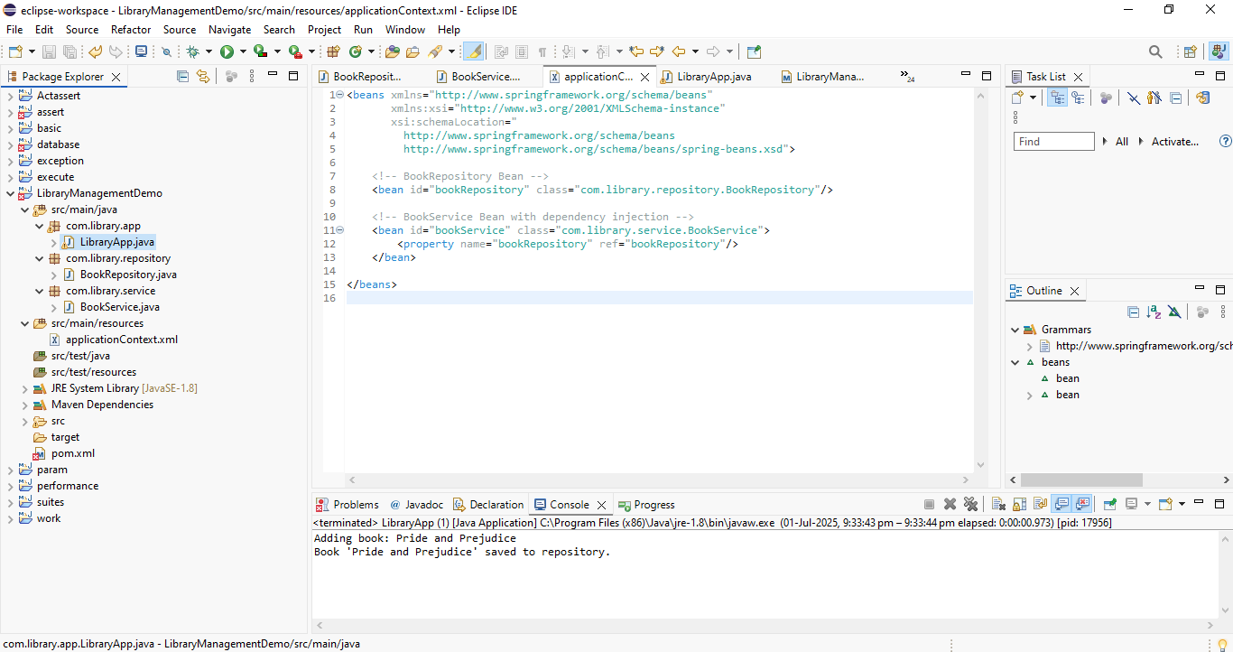

**Exercise 6: Configuring Beans with Annotations**

**Scenario:**

You need to simplify the configuration of beans in the library management application using annotations.

**SOLUTION:**

**applicationContext.xml**

<beans xmlns="http://www.springframework.org/schema/beans"

xmlns:xsi="http://www.w3.org/2001/XMLSchema-instance"

xmlns:context="http://www.springframework.org/schema/context"

xsi:schemaLocation="

http://www.springframework.org/schema/beans

http://www.springframework.org/schema/beans/spring-beans.xsd

http://www.springframework.org/schema/context

http://www.springframework.org/schema/context/spring-context.xsd">

<!-- Enable annotation-based configuration -->

<context:component-scan base-package="com.library" />

</beans>

**BookRepository.java**

package com.library.repository;

import org.springframework.stereotype.Repository;

@Repository

public class BookRepository {

public void saveBook(String bookName) {

System.out.println("Book '" + bookName + "' saved to repository.");

}

}

**BookService.java**

package com.library.service;

import org.springframework.beans.factory.annotation.Autowired;

import org.springframework.stereotype.Service;

import com.library.repository.BookRepository;

@Service

public class BookService {

// Automatically inject BookRepository using @Autowired

@Autowired

private BookRepository bookRepository;

public void addBook(String bookName) {

System.out.println("Adding book: " + bookName);

bookRepository.saveBook(bookName);

}

}

**LibraryApp.java**

package com.library.app;

import org.springframework.context.ApplicationContext;

import org.springframework.context.support.ClassPathXmlApplicationContext;

import com.library.service.BookService;

public class LibraryApp {

public static void main(String[] args) {

ApplicationContext context = new ClassPathXmlApplicationContext("applicationContext.xml");

BookService bookService = context.getBean(BookService.class);

bookService.addBook("The Great Gatsby");

}

}

**Pom.xml**

<dependencies>

<dependency>

<groupId>org.springframework</groupId>

<artifactId>spring-context</artifactId>

<version>5.3.34</version>

</dependency>

</dependencies>

**OUTPUT:**

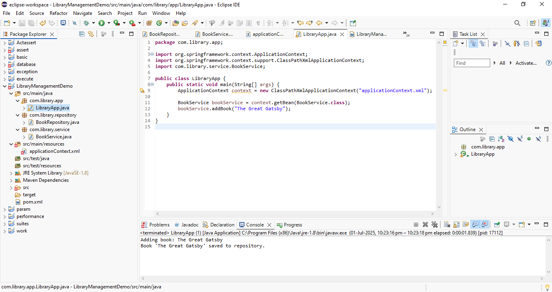

**Exercise 7: Implementing Constructor and Setter Injection**

**Scenario:**

The library management application requires both constructor and setter injection for better control over bean initialization.

**SOLUTION:**

**pom.xml**

<dependencies>

<dependency>

<groupId>org.springframework</groupId>

<artifactId>spring-context</artifactId>

<version>5.3.32</version> <!-- Or latest compatible version -->

</dependency>

</dependencies>

**BookRepository.java**

package com.library.repository;

import java.util.Arrays;

import java.util.List;

public class BookRepository {

public List<String> findAllBooks() {

return Arrays.asList("Book 1", "Book 2", "Book 3");

}

}

**BookService.java**

package com.library.service;

import com.library.repository.BookRepository;

public class BookService {

private BookRepository bookRepository;

// Constructor Injection

public BookService(BookRepository bookRepository) {

this.bookRepository = bookRepository;

}

// Setter Injection

public void setBookRepository(BookRepository bookRepository) {

this.bookRepository = bookRepository;

}

public void listBooks() {

bookRepository.findAllBooks().forEach(System.out::println);

}

}

**LibraryApp.java**

package com.library.app;

import org.springframework.context.ApplicationContext;

import org.springframework.context.support.ClassPathXmlApplicationContext;

import com.library.service.BookService;

public class LibraryApp {

public static void main(String[] args) {

ApplicationContext context = new ClassPathXmlApplicationContext("applicationContext.xml");

BookService bookService = context.getBean("bookService", BookService.class);

bookService.listBooks();

}

}

**applicationContext.xml**

<?xml version="1.0" encoding="UTF-8"?>

<beans xmlns="http://www.springframework.org/schema/beans"

xmlns:xsi="http://www.w3.org/2001/XMLSchema-instance"

xsi:schemaLocation="

http://www.springframework.org/schema/beans

http://www.springframework.org/schema/beans/spring-beans.xsd">

<bean id="bookRepository" class="com.library.repository.BookRepository" />

<bean id="bookService" class="com.library.service.BookService">

<!-- Constructor Injection -->

<constructor-arg ref="bookRepository" />

<!-- Setter Injection -->

<property name="bookRepository" ref="bookRepository" />

</bean>

</beans>

**OUTPUT:**

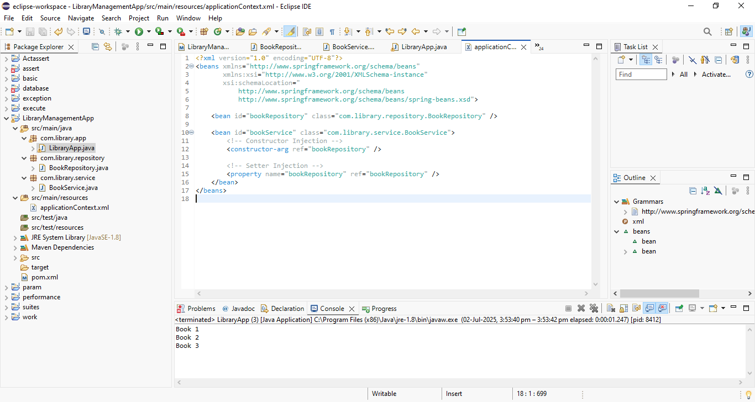

**Exercise 8: Implementing Basic AOP with Spring**

**Scenario:**

The library management application requires basic AOP functionality to separate cross-cutting concerns like logging and transaction management.

**SOLUTION:**

**pom.xml**

<dependencies>

<!-- Existing Spring Context -->

<dependency>

<groupId>org.springframework</groupId>

<artifactId>spring-context</artifactId>

<version>5.3.32</version>

</dependency>

<!-- Add Spring AOP -->

<dependency>

<groupId>org.springframework</groupId>

<artifactId>spring-aop</artifactId>

<version>5.3.32</version>

</dependency>

<!-- AspectJ Weaver -->

<dependency>

<groupId>org.aspectj</groupId>

<artifactId>aspectjweaver</artifactId>

<version>1.9.21</version>

</dependency>

</dependencies>

**LoggingAspect.java**

package com.library.aspect;

import org.aspectj.lang.annotation.After;

import org.aspectj.lang.annotation.Aspect;

import org.aspectj.lang.annotation.Before;

@Aspect

public class LoggingAspect {

@Before("execution(* com.library.service.BookService.*(..))")

public void beforeMethod() {

System.out.println("🔍 [AOP] Before method execution");

}

@After("execution(* com.library.service.BookService.*(..))")

public void afterMethod() {

System.out.println("✅ [AOP] After method execution");

}

}

**applicationContext.xml**

<?xml version="1.0" encoding="UTF-8"?>

<beans xmlns="http://www.springframework.org/schema/beans"

xmlns:xsi="http://www.w3.org/2001/XMLSchema-instance"

xmlns:aop="http://www.springframework.org/schema/aop"

xsi:schemaLocation="

http://www.springframework.org/schema/beans

http://www.springframework.org/schema/beans/spring-beans.xsd

http://www.springframework.org/schema/aop

http://www.springframework.org/schema/aop/spring-aop.xsd">

<!-- Enable AspectJ auto proxy -->

<aop:aspectj-autoproxy />

<!-- Repository bean -->

<bean id="bookRepository" class="com.library.repository.BookRepository" />

<!-- Service bean -->

<bean id="bookService" class="com.library.service.BookService">

<constructor-arg ref="bookRepository"/>

<property name="bookRepository" ref="bookRepository"/>

</bean>

<!-- Logging Aspect -->

<bean id="loggingAspect" class="com.library.aspect.LoggingAspect" />

</beans>

**LibraryApp.java**

package com.library.app;

import org.springframework.context.ApplicationContext;

import org.springframework.context.support.ClassPathXmlApplicationContext;

import com.library.service.BookService;

public class LibraryApp {

public static void main(String[] args) {

ApplicationContext context = new ClassPathXmlApplicationContext("applicationContext.xml");

BookService bookService = context.getBean("bookService", BookService.class);

bookService.listBooks();

}

}

**OUTPUT:**

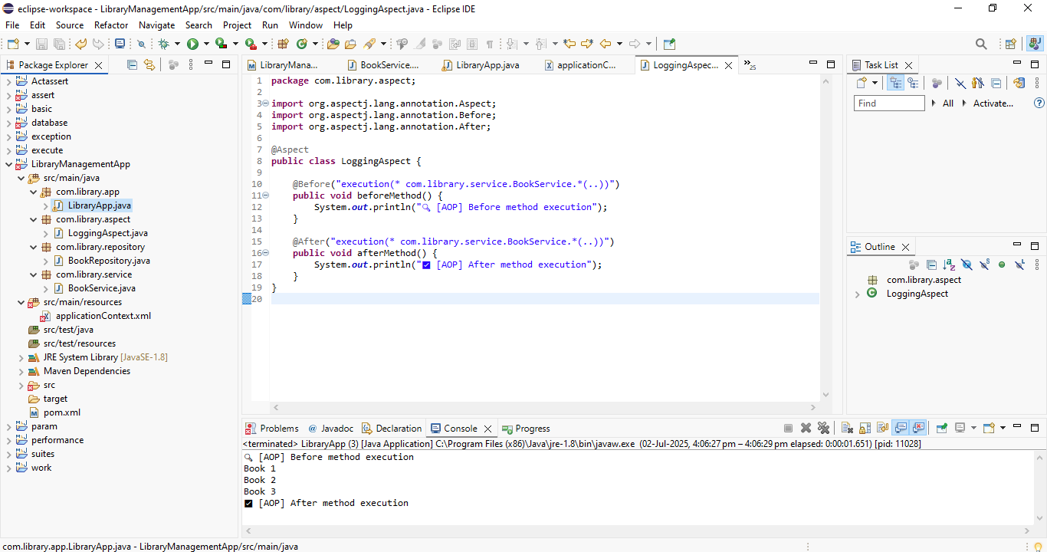

**Exercise 9: Creating a Spring Boot Application**

**Scenario:**

You need to create a Spring Boot application for the library management system to simplify configuration and deployment.

**SOLUTION:**

**pom.xml**

<?xml version="1.0" encoding="UTF-8"?>

<project xmlns="http://maven.apache.org/POM/4.0.0" xmlns:xsi="http://www.w3.org/2001/XMLSchema-instance"

xsi:schemaLocation="http://maven.apache.org/POM/4.0.0 https://maven.apache.org/xsd/maven-4.0.0.xsd">

<modelVersion>4.0.0</modelVersion>

<parent>

<groupId>org.springframework.boot</groupId>

<artifactId>spring-boot-starter-parent</artifactId>

<version>3.5.3</version>

<relativePath/> <!-- lookup parent from repository -->

</parent>

<groupId>com.example</groupId>

<artifactId>LibraryManagement</artifactId>

<version>0.0.1-SNAPSHOT</version>

<name>LibraryManagement</name>

<description>Library Management System</description>

<url/>

<licenses>

<license/>

</licenses>

<developers>

<developer/>

</developers>

<scm>

<connection/>

<developerConnection/>

<tag/>

<url/>

</scm>

<properties>

<java.version>17</java.version>

</properties>

<dependencies>

<dependency>

<groupId>org.springframework.boot</groupId>

<artifactId>spring-boot-starter-data-jpa</artifactId>

</dependency>

<dependency>

<groupId>org.springframework.boot</groupId>

<artifactId>spring-boot-starter-web</artifactId>

</dependency>

<dependency>

<groupId>com.h2database</groupId>

<artifactId>h2</artifactId>

<scope>runtime</scope>

</dependency>

<dependency>

<groupId>org.springframework.boot</groupId>

<artifactId>spring-boot-starter-test</artifactId>

<scope>test</scope>

</dependency>

</dependencies>

<build>

<plugins>

<plugin>

<groupId>org.springframework.boot</groupId>

<artifactId>spring-boot-maven-plugin</artifactId>

</plugin>

</plugins>

</build>

</project>

**LibraryManagementApplication.java**

package com.example.LibraryManagement;

import org.springframework.boot.SpringApplication;

import org.springframework.boot.autoconfigure.SpringBootApplication;

@SpringBootApplication

public class LibraryManagementApplication {

public static void main(String[] args) {

SpringApplication.run(LibraryManagementApplication.class, args);

}

}

**BookController.java**

package com.example.LibraryManagement.controller;

import org.springframework.web.bind.annotation.GetMapping;

import org.springframework.web.bind.annotation.RequestMapping;

import org.springframework.web.bind.annotation.RestController;

import java.util.List;

*@RestController*

*@RequestMapping*("/books")

public class BookController {

*@GetMapping*

public List<String> getBooks() {

return List.*of*("The Alchemist", "The Hobbit", "1984");

}

}

**Book.java**

package com.example.LibraryManagement.model;

import jakarta.persistence.*;

*@Entity*

public class Book {

*@Id*

*@GeneratedValue*(strategy = *GenerationType*.***IDENTITY***)

private Long id;

private String title;

private String author;

private String isbn;

// --- Getters and Setters ---

public Long getId() {

return id;

}

public void setId(Long id) {

this.id = id;

}

public String getTitle() {

return title;

}

public void setTitle(String title) {

this.title = title;

}

public String getAuthor() {

return author;

}

public void setAuthor(String author) {

this.author = author;

}

public String getIsbn() {

return isbn;

}

public void setIsbn(String isbn) {

this.isbn = isbn;

}

}

**BookRepository.java**

package com.example.LibraryManagement.repository;

import com.example.LibraryManagement.model.Book;

import org.springframework.data.jpa.repository.JpaRepository;

import org.springframework.stereotype.Repository;

*@Repository*

public interface BookRepository extends JpaRepository<Book, Long> {

// You can add custom query methods here if needed

}

**application.property.xml**

# App name and port

spring.application.name=LibraryManagement

server.port=8082

# H2 Console

spring.h2.console.enabled=true

spring.h2.console.path=/h2-console

# H2 In-Memory Database

spring.datasource.url=jdbc:h2:mem:librarydb

spring.datasource.driverClassName=org.h2.Driver

spring.datasource.username=sa

spring.datasource.password=

# Hibernate + JPA

spring.jpa.hibernate.ddl-auto=update

spring.jpa.database-platform=org.hibernate.dialect.H2Dialect

spring.jpa.show-sql=true

**import.sql**

INSERT INTO BOOK (title, author, isbn) VALUES ('Java Fundamentals', 'John Doe', '1234567890');

INSERT INTO BOOK (title, author, isbn) VALUES ('Spring Boot Mastery', 'Jane Smith', '0987654321');

INSERT INTO BOOK (title, author, isbn) VALUES ('The Alchemist', 'The Hobbit', '1984');

**OUTPUT:**

